How to install MG’s Unofficial Skins

First of all you need to be using Firefox with the Stylish add-on installed.

1. Open the board in your browser and right click on the Stylish icon in the bottom right corner of the Status bar

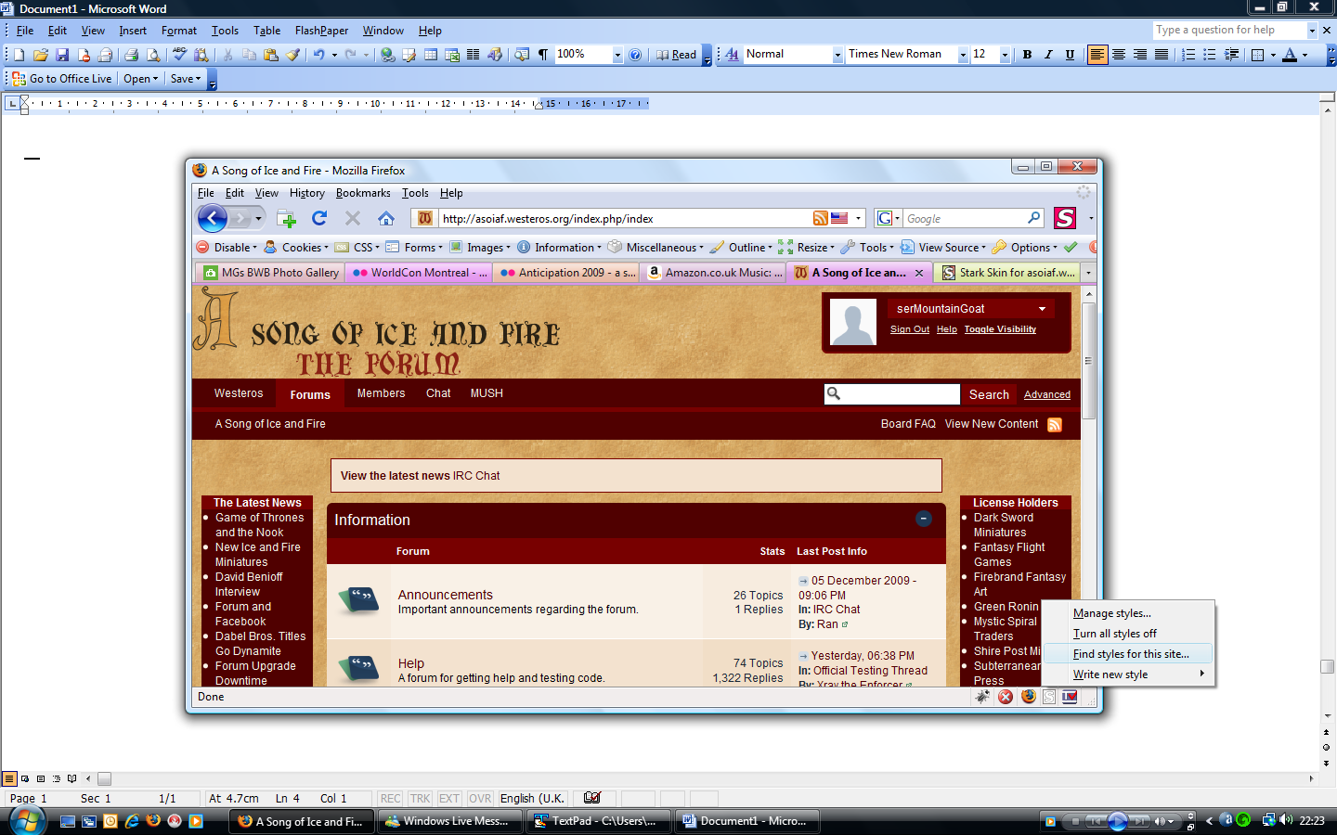

Stylish Icon

2. Click “Find styles for this site…” this will perform a search on the userstyles website

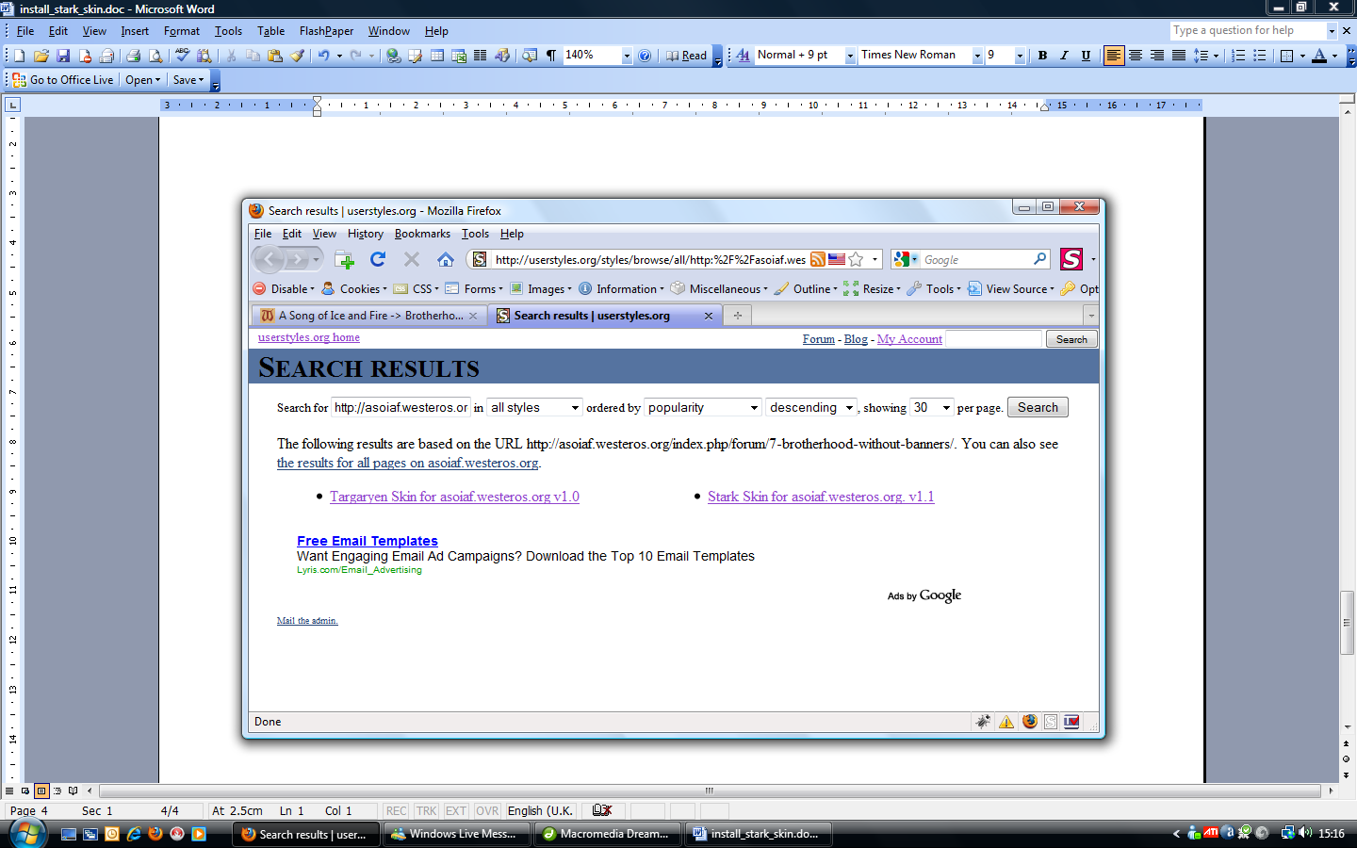

3. Click on the link for the Skin you wish to use, this will display the following page which shows the version history of the Skin with a list of changes.

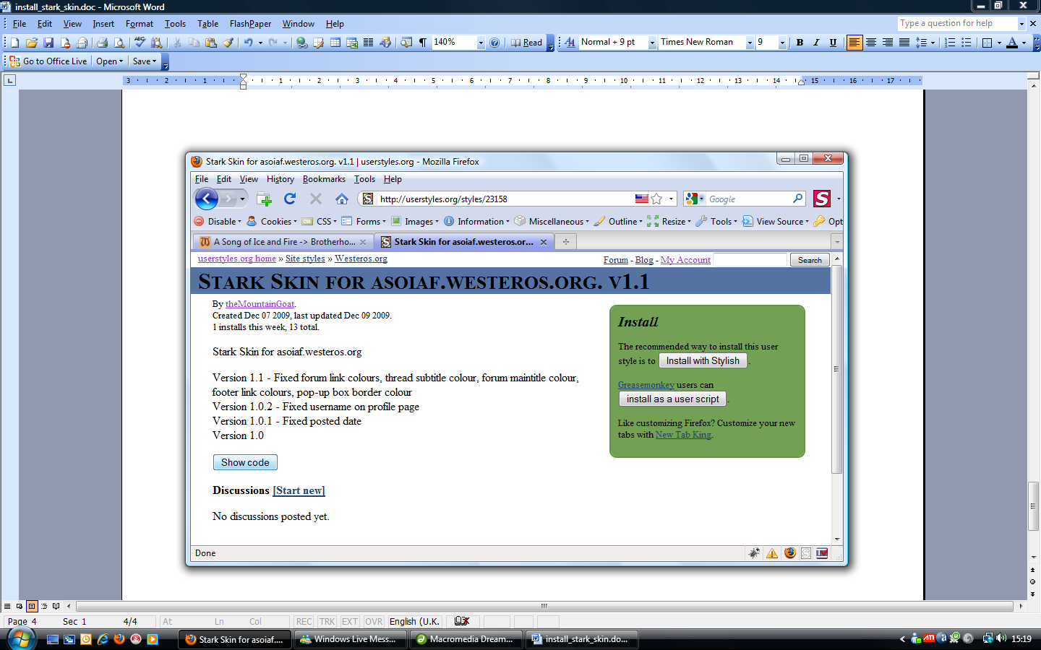

4. Click on the “Show code” button and this will display the style code. Select all of the code in this box and copy it, either with a right click and select “copy” or with CTRL+C keyboard command.
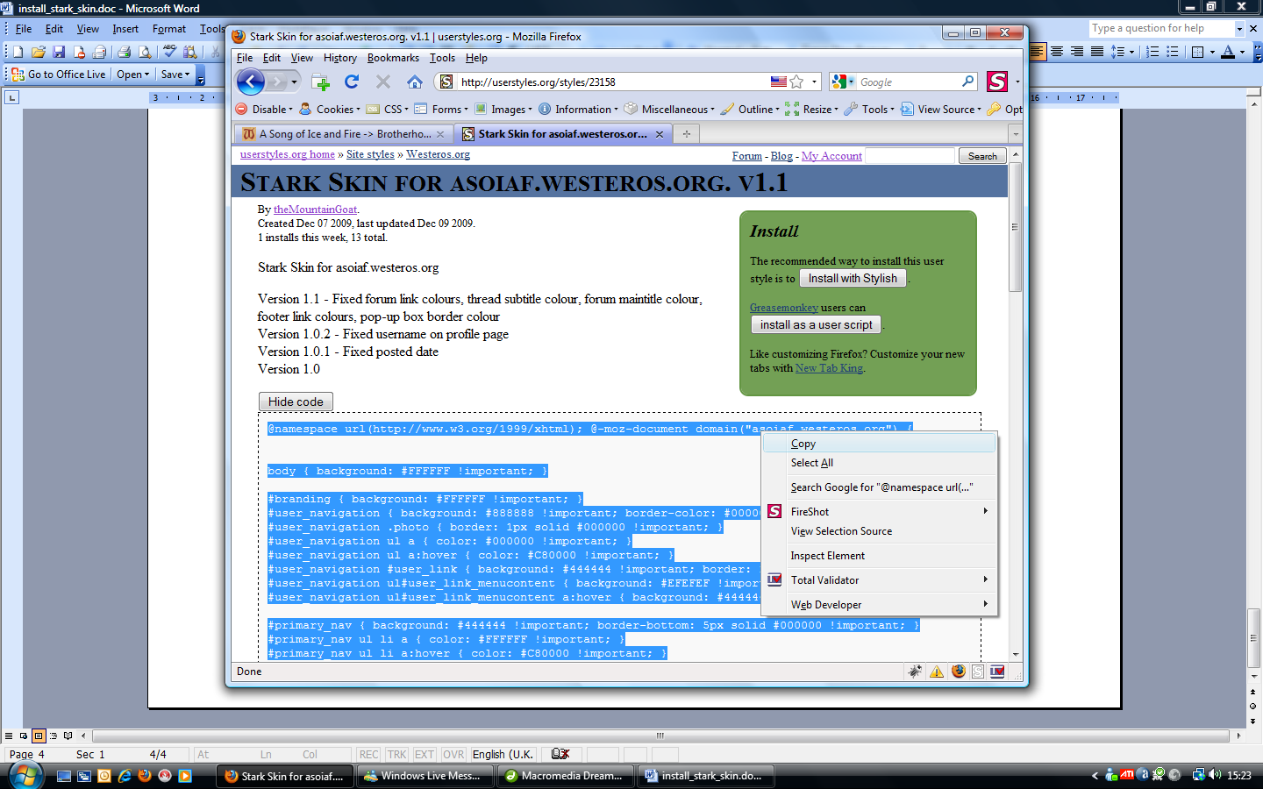

5. Close the userstyles tab and return to Westeros. Again right click on the Stylish icon and this time hover over the “Write new style” menu and then select “For asoiaf.westeros.org…”

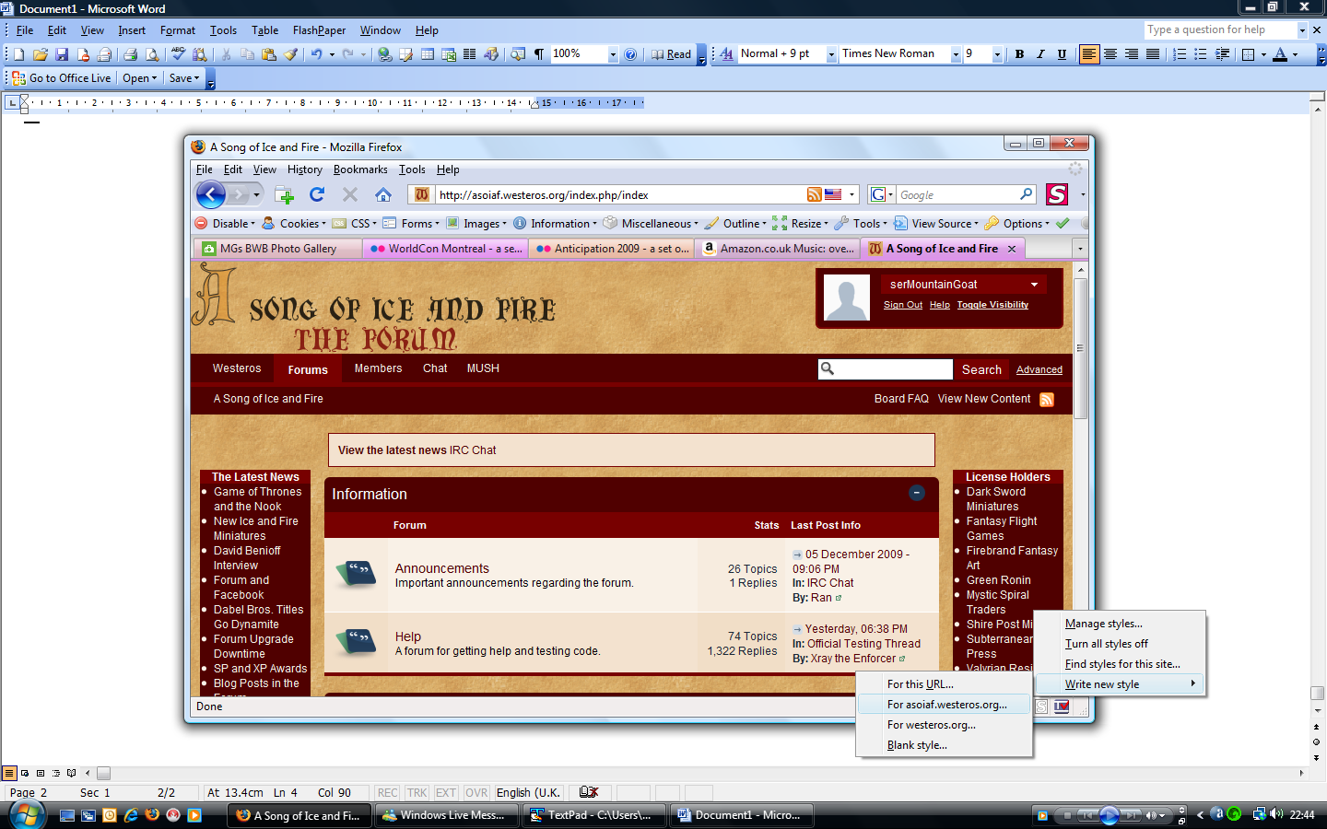
Select this option

6. Enter a name for your New Style, I recommend using the skin name and version number so you know which version you have installed in your browser. You can check my sig to see if there are any new versions available.

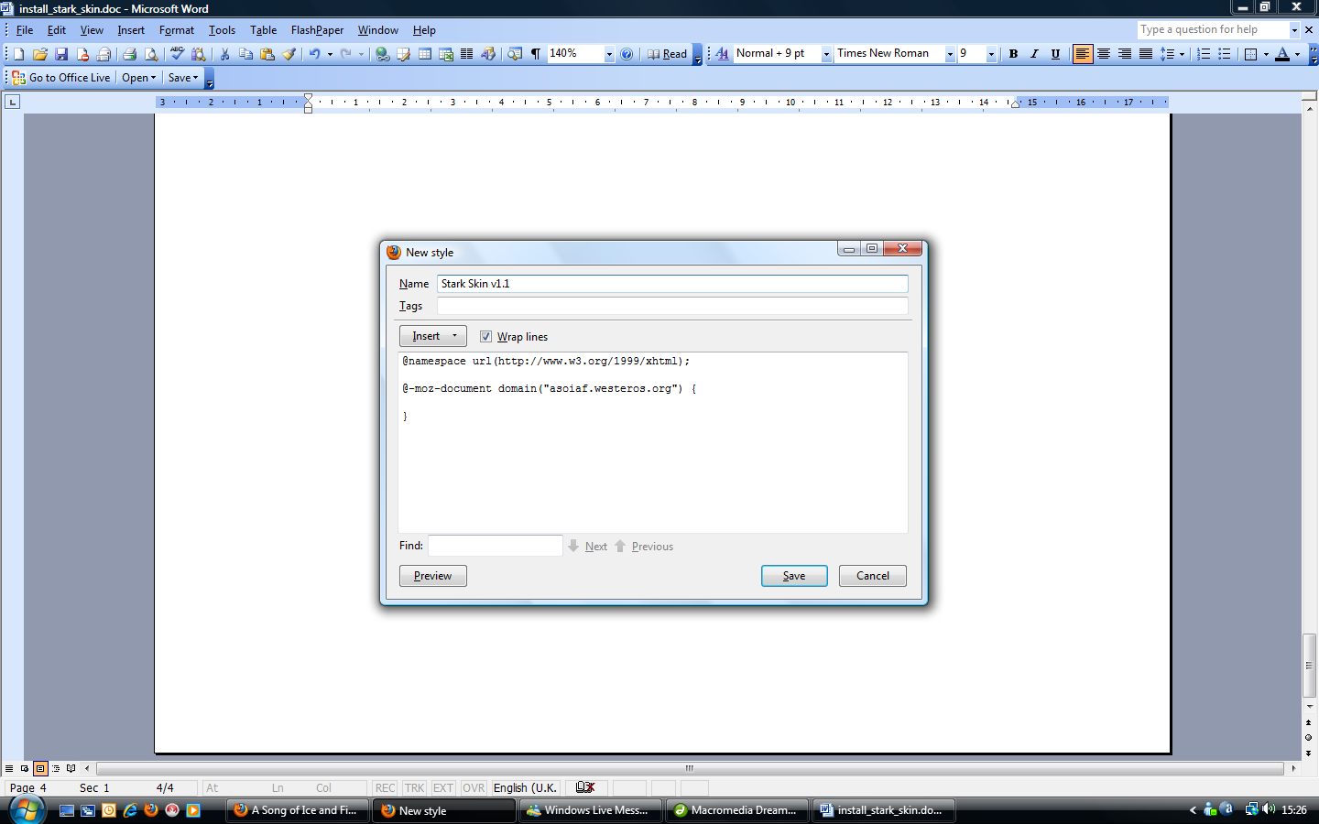
7. Delete the code that is already in this box so that it is empty

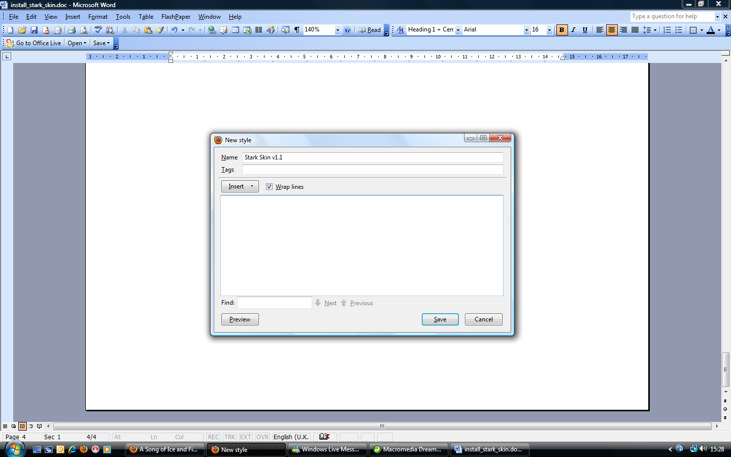

8. Paste the code that you Copied in step 4 into this empty box with the CTRL+V keyboard command

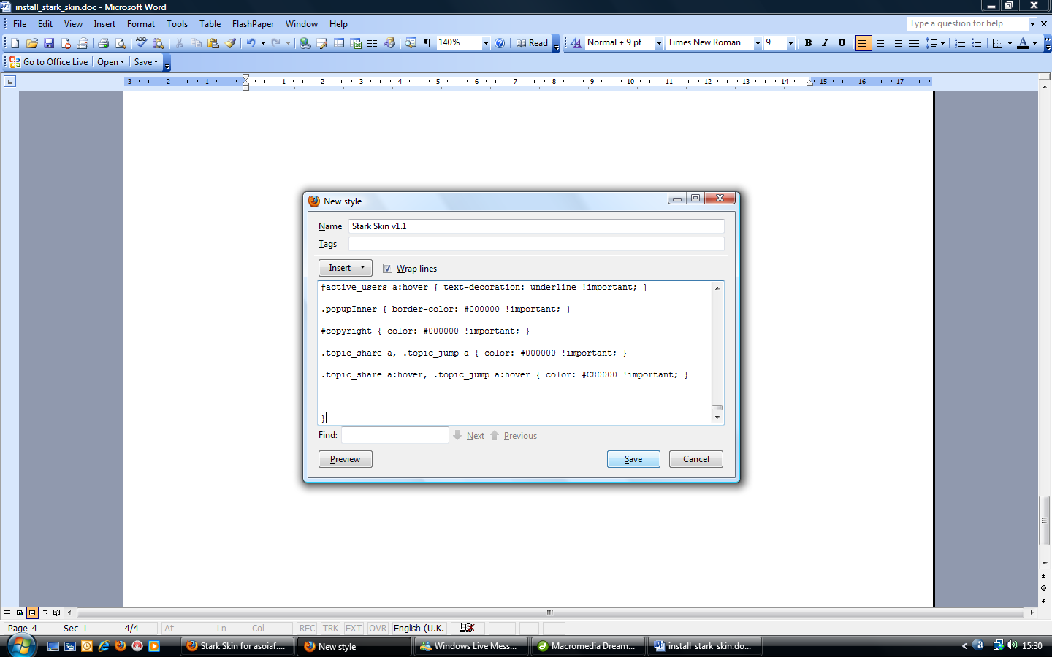

9. Click the “Save” button and voila you should now see Westeros in the new skin.

Stark Skin:

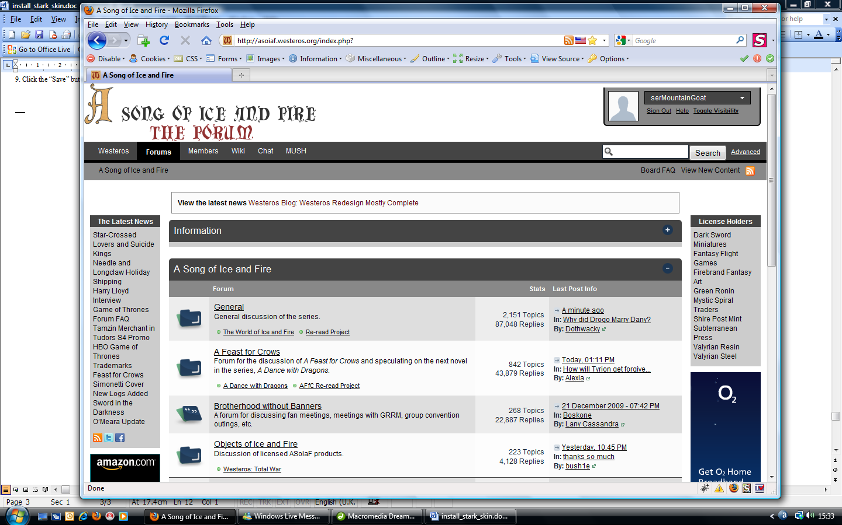

Targaryen Skin:

